A

Project Mid-Term Report

On

**Note Sharing System**

For the partial fulfillment of the requirements for the degree of Bachelor of Computer Engineering Under Pokhara University

**Submitted to**

Department of Computer Engineering

National Academy of Science and Technology

**Under the supervision of**

Mr. Sunil Bahadur Bist

Lecturer, Department of Computer Engineering

**Submitted by**

Binod Raj Pant (22070199)

BE Computer, 6th Semester

June, 2025

|  |  |
| --- | --- |
|  | **National Academy of Science and Technology**  (Affiliated to Pokhara University)  Accredited by University Grants Commission (UGC), Nepal (2022)  Uttarbehedi-4 Dhangadhi, Kailali, Nepal |

**STUDENT DECLARATION**

I, Binod Raj Pant, a student of Bachelor of Computer Engineering, 6th semester, hereby declare that the project entitled **“Note Sharing System”** is the result of my independent work and has been carried out under the supervision of Mr. Sunil Bahadur Bist

I further affirm that this project report has not been submitted, either wholly or partially, to any other institution or organization for the purpose of obtaining any academic degree or certification. All sources of information and references used in the preparation of this report have been properly cited and acknowledged to the best of my knowledge and belief.

**SUPERVISOR ACCEPTANCE**

This is to certify that the project report entitled **“Note Sharing System”**, submitted by **Mr. Binod Raj Pant**, a student of Bachelor of Computer Engineering, 6th semester, has been carried out under my supervision.

To the best of my knowledge, the project embodies the student’s original work and meets the academic standards required for the partial fulfillment of the Bachelor’s Degree in Computer Engineering. I, therefore, recommend the project for final evaluation.

**Mr. Sunil Bahadur Bist**  
**Project Supervisor,**  
Lecturer,  
Department of Computer Engineering  
National Academy of Science and Technology   
Uttarbehedi-4 Dhangadhi, Kailali, Nepal

**APPROVAL CERTIFICATE**

This is to certify that the project report entitled **“Note Sharing System”**, prepared by **Mr. Binod Raj Pant** in partial fulfillment of the requirements for the degree of **Bachelor of Computer Engineering**, has been evaluated by the project committee.In our opinion, the project is satisfactory in terms of scope, content, and quality, and meets the academic standards set forth for the award of the degree.

|  |  |
| --- | --- |
| **Mr. Sunil Bahadur Bist**  Lecturer , Department of Computer Engineering NAST, Dhangadhi | **Er. Ravi Khadka**  Head of Department, Department of Computer Engineering NAST, Dhangadhi |

**ACKNOWLEDGEMENT**

I am very grateful to the department of computer Engineering, NAST college for providing me an opportunity to work on a minor project as part of Project ‘I’. I am delighted to express my deep sense of gratitude and gratefulness to our academic sir **Mr. Sunil Bahadur Bist** for his invaluable guidance, encouragement, and even monitoring to spare time despite his busy schedule for project progress reviews.

Furthermore, I would like to thank all the faculty members of the Department for Computer Engineering, who have willingly shared their precious time, advice, and encouragement during planning of this project.

In addition, I am profoundly grateful to my family for unwavering support, patient, and encouragement as well as motivation during the course of their of project.

With Regards

**Binod Raj Pant** [22070199]

**ABSTRACT**

The **Note Sharing System** is a web-based platform designed to streamline the digital exchange of academic notes among students and faculty members. It addresses the limitations of traditional note-sharing practices, such as printed materials, scattered digital files, and lack of accessibility, by offering a centralized, secure, and organized digital repository.

The system leverages modern web technologies to facilitate the uploading, categorization, and retrieval of notes based on academic subjects or courses. It employs role-based access control to ensure differentiated access for general users and administrators, thereby maintaining content integrity and system security. Users can contribute educational materials in various formats, including PDF and DOCX, while also benefiting from features like search functionality and structured navigation.

By automating note management and eliminating the reliance on physical documents, the Note Sharing System significantly reduces administrative burden, enhances accessibility, and supports environmentally sustainable practices. Moreover, it fosters collaborative learning by enabling users to share insights, discuss content, and build a richer academic resource base. The system also emphasizes security and scalability by integrating encrypted data storage, backup mechanisms, and modular architecture.

In essence, the Note Sharing System contributes to improving academic efficiency, encouraging knowledge exchange, and promoting sustainable digital education in university environments.

*****Keywords****: Note Sharing System, academic resources, digital education, role-based access, collaborative learning, file management, educational automation.***

**List of Abbreviations**

|  |  |
| --- | --- |
| CSS | Cascading Style Sheets |
| DOCX | Document Open XML |
| ERD | Entity Relationship Diagram |
| HTML | HyperText Markup Language |
| MVT | Model View Template |
| MYSQL | My Structured Query Language |
| NAST | National Academy of Science and Technology |
| ORM | Object Relational Mapping |
| PDF | Portable Document Format |
| UI | User Interface |

**Table of Figures**

Fig 1 :System Design 8

Fig 2 :ER Diagram 9

Fig 3 :Index Page 9

Fig 4 : Register Page 10

Fig 5 : Login page 10

Fig 6 :Upload Note 10

Fig 7 : View My Notes 10

Fig 8 :View All Notes 11

Fig 9 :User Dashboard 11

Fig 10 : Admin Dashboard 11

**List of Tables**

Table 1 : Gantt Chart 6

Table 2 : Test Cases …. 27

**Table of Contents**

Student Declaration.....................................................................................…..............i

Supervisor Acceptance................................................................................…..............ii

Approval Certificate..............................…..................................................…..............iii

Acknowledgement............................................................................….........................iv

Abstract…………............................................................................….........................v

List of Abbreviations ............................................................…...................................vi

List of Figure ...............................................................................................................vii

List of Tables...............................................................................................................viii

1. Chapter .............................................................................................…/..................1

Introduction ................…......................................................................…/..................1

1.1. Background............................................….....................................….…....1

1.2. Objectives ...........................................................................................…...2

1.3. Purpose, Scope, And Applicability ...............................…............…..…..2

1.3.1. Purpose.........................................................................................……....2

1.3.2. Scope and Limitation ................................................….....................….3

1.3.3. Applicability ...............................................................................…...…4

1.4. Achievements....................................................................................….....5

1.5. Organization of Report...............................................................................5

2. Chapter .......................................................................................................……....7

Survey of Technologies .............................….................................................……....7

3. Chapter ......................................................................................................…........17

Requirements and Analysis.................….......................................................…........17

3.1 Problem Definition.................................................................………........17

3.2 Requirement specifiaction .....................................................………........17

3.3 Planning and scheduling.....................................................……….……...17

3.4 System Requirements.....................................................………..……......17

3.5 Prelimanary Product description....................................………..……......17

4. Chapter ...................................................................................................…...........19

Design.........................................................................................................................19

4.1 Introduction.................……………………..................………...……......17

4.2 System Design.................……………………..................….……..…......17

4.3 Database Design.................……………………..................…….…….....17

4.4 Interface Design.................……………………..................…………......17

5. Chapter ...................................................................................................…...........19

Implementation and Testing.......................................................................................19

5.1 Implementation Approaches……………………..................…...……......17

5.2 Coding Details and Code Efficiency………………..........….……..…......17

5.2.1 Code Efficiency………………..........….…..…......17

5.3 Testing Approach………………..........….……..…..........….……..…......17

5.3.1 Unit Testing……………..……..........….…..…......17

5.3.2 Integrated Testing……………...........….…..…......17

5.3.3 Beta Testing………………..........….…………......17

5.4 Modifications and Improvements………...……..…..........….……..….....17

5.5 Test Cases………...……..….....…..........….........…..........….……..….....17

6. Chapter .......................................................................................…................…...19

System Analysis And Design.....................................................................................19

6.1 Test Reports................................................................................................19

6.2. User Documentation .........................................................................…....22

7. Chapter .......................................................................................…................…...19

Conclusions............................................................….............................................19

7.1 Conclusion ..........................................................................…............19

7.2. Significance of the System.........................................................…....22

7.3. Recommandation........................................................................…....22

References.....................................….....................….............................................32

1. **CHAPTER**

**INTRODUCTION**

* 1. **Background**

The **Note Sharing System** is a centralized, web-based platform designed to streamline the process of academic note distribution between students and faculty. It addresses common challenges found in traditional note-sharing practices, such as reliance on physical documents, lack of standardization, limited accessibility, and poor organization of resources. By automating the sharing and management of educational materials, this system enhances knowledge exchange, promotes digital learning, and fosters academic collaboration within an institution.

Built using modern web technologies, the system supports uploading, categorizing, searching, and retrieving academic notes by course or subject. It ensures secure storage of documents and provides differentiated access through role-based permissions. The platform encourages student participation, facilitates resource availability, and supports environmentally friendly practices by reducing the use of printed materials.

* 1. **Objectives**

To develop a Note Sharing System that enables easy, reliable, and centralized exchange of academic notes with a focus on user convenience and secure access.

* 1. **Purpose,Scope and Applicability**
     1. **Purpose**

The purpose of this system is to digitize and streamline the distribution of academic notes, ensuring equal access to learning materials for all students. It simplifies the management of educational content, encourages resource sharing among students and faculty, and supports institutional goals related to digital transformation in education.

* + 1. **Scope and Limitation**

**Scope:**

* Enables students to upload and access notes based on courses, departments.
* Supports multiple document formats such as PDF, DOCX.
* Allows administrators to monitor and manage uploaded content.
* Incorporates search, filter, and categorization features for ease of use.

**Limitations:**

* Requires stable internet connectivity for optimal use.
* Does not perform content plagiarism or quality checks automatically.
* Limited file size support depending on server configuration.
* Primarily designed for academic institutions; may need customization for other domains.
* Not much matured, built as a mini project.
  + 1. **Applicability**

The system is applicable to:

* Colleges and universities aiming to digitalize their academic content management.
* Students seeking a centralized location to access or contribute notes.
* Faculty members wishing to distribute reference materials or lecture notes.
* Educational institutions looking to implement environmentally friendly practices.
  1. **Achievements**
* Successfully designed and implemented a user-friendly web application.
* Achieved seamless role-based access for users and admin.
* Reduced paper usage by promoting digital resource sharing.
  1. **Organization of Report**

This report is systematically divided into the following seven chapters:

**1. Chapter – Introduction**   
Provides a comprehensive overview of the Note Sharing System including its background, objectives, purpose, scope, applicability, achievements, and the structure of the report.

**2. Chapter – Survey of Technologies**   
Describes the technologies used in the development of the system, including frontend, backend, database, and security components relevant to web-based applications.

**3. Chapter – Requirements and Analysis**  
Covers the identification of the problem, functional and non-functional requirements, system planning and scheduling, hardware/software requirements, and an initial description of the product.

**4. Chapter – Design**   
Includes the system design, architectural overview, data models (ERD), and user interface layout with necessary diagrams.

**5. Chapter – Implementation and Testing**   
Explains the implementation methodology, coding techniques, testing strategies, test cases, modifications, and overall development flow.

**6. Chapter – Results and Evaluation**   
Evaluates the functionality, usability, and effectiveness of the system through system evaluation and user feedback, and outlines both strengths and limitations.

**7. Chapter – Conclusion and Future Work**   
Summarizes the entire project, highlights its significance, and provides suggestions for future improvements and scalability.

**References**   
Lists the books, research papers, and online resources referred to throughout the project.

1. **CHAPTER**

**SURVEY OF THECHNOLOGIES**

To better understand the landscape of academic note-sharing systems, a review of similar platforms particularly within Nepal was conducted. These platforms inspired certain ideas and also revealed limitations that the **Note Sharing System** aimed to overcome.

#### ****1. BSCCIT Note (bsccitnote.com)****

**Overview:**  
BSCCIT Note is a community-driven platform focused on providing Bachelor of Science in Computer Science and Information Technology (BSc.CSIT) notes, model questions, and past papers.

**Strengths:**

* Wide collection of subject-wise materials.
* Community support for uploading and sharing resources.
* Simple and accessible interface.

**Limitations:**

* Lacks user authentication and role-based control.
* Not interactive—no user feedback, rating, or discussion feature.
* Limited content filtering/searching mechanisms.

#### ****2. StudyNotesNepal (studynotesnepal.com)****

**Overview:**  
A comprehensive portal offering notes for various university programs (TU, PU, KU, etc.) including BBA, BIM, CSIT, and more.

**Strengths:**

* Covers a wide range of faculties and subjects.
* Well-organized by course and semester.
* Integrated blog posts and career guidance.

**Limitations:**

* Heavily ad-based; commercialized layout can be distracting.
* No user-uploading feature; only admin/owner can post content.
* Limited interactivity or system customization.

#### ****3. BSCCSIT Blog (bsccsit.com)****

**Overview:**  
A blog-based platform maintained by students to share CSIT course materials, tutorials, and personal experiences.

**Strengths:**

* Student-centered and regularly updated.
* Includes programming examples, projects, and resources.

**Limitations:**

* Not a structured note-sharing platform.
* Difficult to search specific course notes.
* Mostly limited to blog-style posts, not organized documents.

#### ****4. Kailaba (kailaba.com)****

**Overview:**  
An educational website developed to serve as a digital academic platform, especially for students in Far-Western Nepal. It offers notes, results, videos, and other materials.

**Strengths:**

* Region-specific support and content.
* Includes entrance preparation materials and results.

**Limitations:**

* Not user-generated; limited scope of interaction.
* Content is often outdated or incomplete.
* UI is not responsive or modernized.

1. **CHAPTER**

**REQUIREMENTS AND ANALYSIS**

* 1. **Problem Definition**

In traditional academic environments, students often struggle to access quality notes, especially during exam preparation or remote learning situations. The most common methods of sharing notes—through photocopies, personal messages, or social media—are disorganized, unreliable, and lack any form of central management. Furthermore, faculty members face challenges in distributing supplementary materials to all students effectively.

These issues lead to unequal access to learning resources, wasted time, duplication of efforts, and loss of important academic content. There is a clear need for a structured, secure, and easily accessible system to manage the distribution and retrieval of academic notes across an institution.

* 1. **Reqirement Specification**

**Functional Requirements**

1. User Management
2. Notes management
3. Category management
4. Subject management
5. File management
6. Search and filtering by subject

**Non-Functional Requirements**

1. Scalability
2. Response time
3. Easy UI
   1. **Planning and scheduling**

This project schedule has been designed as per the requirements and constraints involved. This project is scheduled to be completed in about 3 months. This project starts form the second week of May, 2025 and goes to fourth week of July, 2025 where there is final Defense.

|  |  |  |  |  |  |  |  |  |  |  |  |
| --- | --- | --- | --- | --- | --- | --- | --- | --- | --- | --- | --- |
| **Activities** | **May** | | | **June** | | | | **July** | | | |
| W 2 | W 3 | W 4 | W 1 | W 2 | W 3 | W 4 | W 1 | W 2 | W 3 | W 4 |
| Project analysis |  |  |  |  |  |  |  |  |  |  |  |
| Feasibility Study |  |  |  |  |  |  |  |  |  |  |  |
| Proposal Submission |  |  |  |  |  |  |  |  |  |  |  |
| Proposal defense |  |  |  |  |  |  |  |  |  |  |  |
| Designing |  |  |  |  |  |  |  |  |  |  |  |
| Coding |  |  |  |  |  |  |  |  |  |  |  |
| Mid-term defense |  |  |  |  |  |  |  |  |  |  |  |
| Testing |  |  |  |  |  |  |  |  |  |  |  |
| Final Testing |  |  |  |  |  |  |  |  |  |  |  |
| Documentation |  |  |  |  |  |  |  |  |  |  |  |
| Final Defense |  |  |  |  |  |  |  |  |  |  |  |

Table 1: Gantt Chart

* 1. **System requirements**

#### ****Software Requirements:****

* Operating System: Windows/Linux
* Backend: Django (Python)
* Frontend: HTML, CSS, JavaScript, Bootstrap
* Database: SQLite (default Django DB)
* Browser: Chrome, Firefox, Edge, Brave (any)
* Code Editor: VS Code, PyCharm (optional)

#### ****Hardware Requirements:****

* Processor: Intel i3 or higher
* RAM: 4 GB minimum
* Hard Disk: Minimum 2 GB free space
* Internet: Required for system access and deployment
  1. **Preliminary product description**

The **Note Sharing System** is a web-based application that provides a centralized platform for students and faculty to share academic notes securely and efficiently. Users can upload, browse, and download notes by filtering based on academic subjects or courses. The system supports multiple roles, with specific access controls, ensuring that data remains secure and manageable.

The product enhances learning accessibility, encourages collaborative resource sharing, and reduces paper usage by promoting digital note distribution. It is designed to be lightweight, easy to navigate, and scalable for future enhancements such as mobile integration or cloud-based storage.

1. **CHAPTER**

**DESIGN**

* 1. **Introduction**

The design phase is crucial in software development as it defines the architecture and blueprint of the system. A well-thought-out design ensures that the application is scalable, maintainable, and efficient. In the Note Sharing System, the design process encompasses system architecture, database structure, and user interface design. This chapter elaborates on how different components are structured to achieve seamless functionality.

* 1. **System Design**

In this phase the general concept or flow of system is Designed. We studied the stakeholder related to the Note Sharing system. The conceptual design of this system is as below:

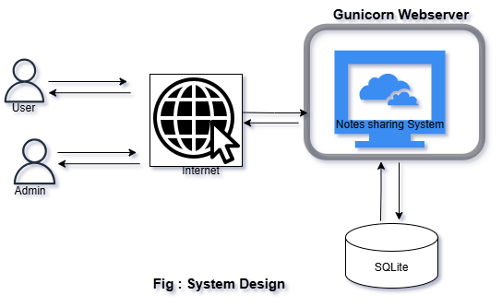

Fig 1: System Design

* 1. **Database Design**

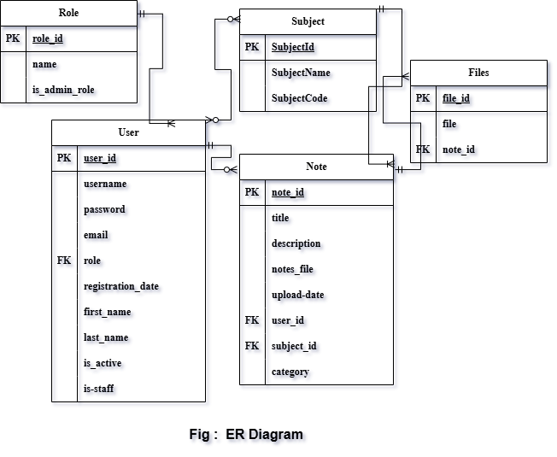

Fig 2: ER Diagram

* 1. **Interface Design**

The user interface (UI) is designed using **Bootstrap** to ensure consistency, responsiveness, and ease of navigation. The interface follows minimalist design principles to avoid distractions and support intuitive usage.

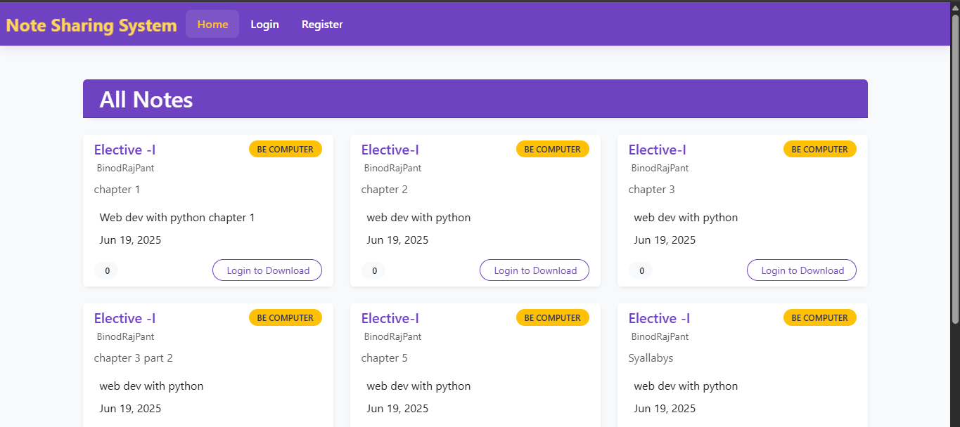

Fig 3: Index Page

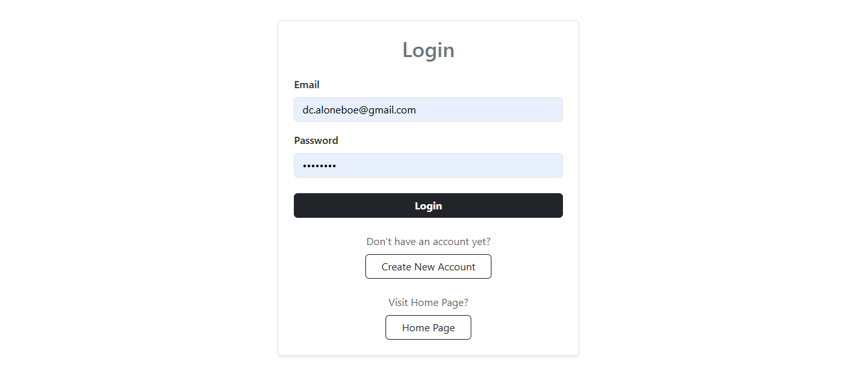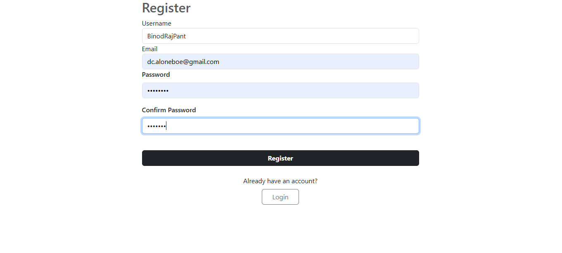

Fig 4: Register Page

Fig 5: LoginPage

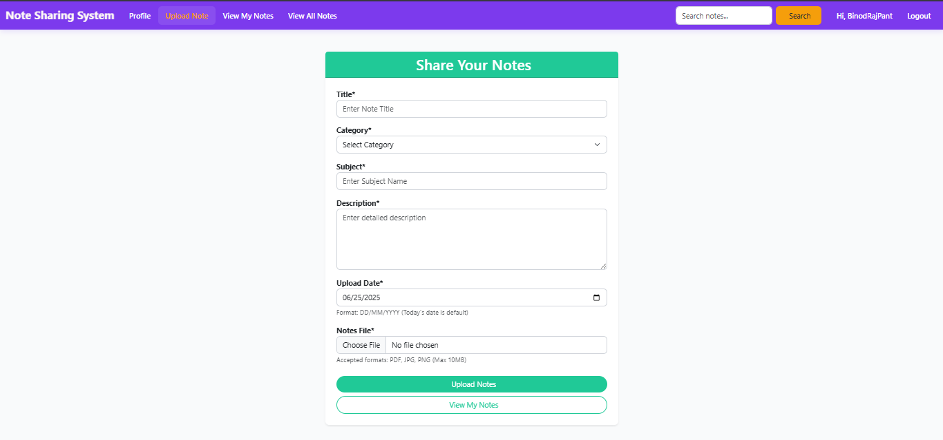

Fig 6: Upload Note

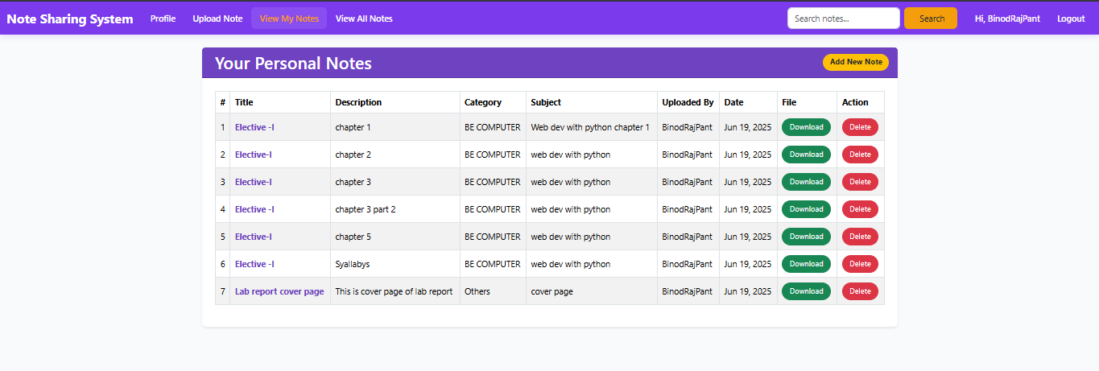

Fig 7: View My Notes

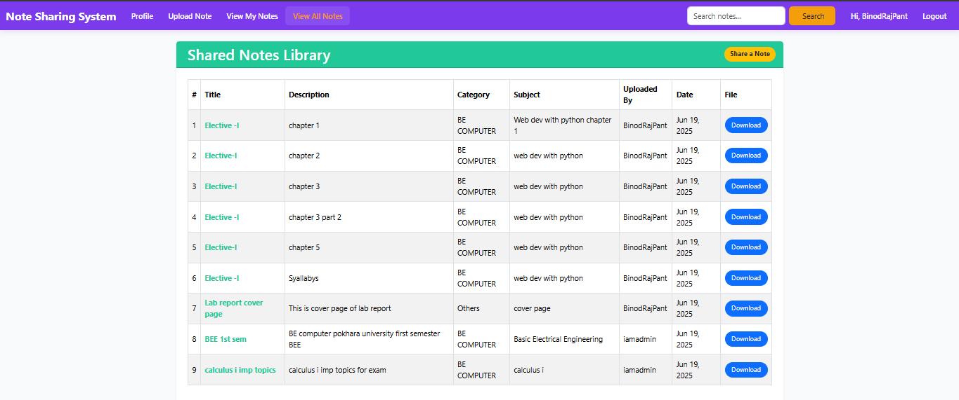

Fig 8: View All notes

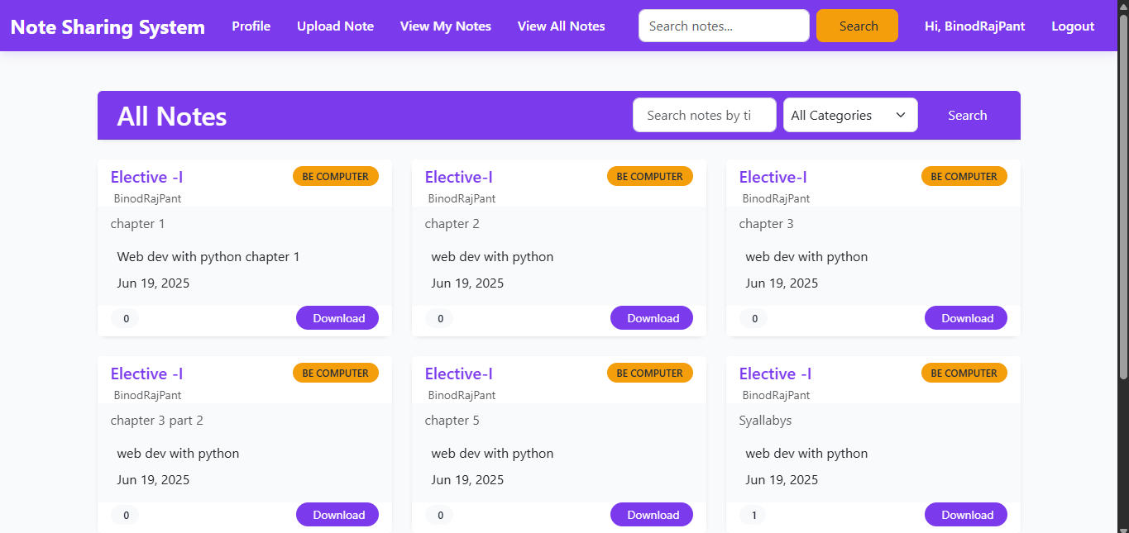

Fig 9: User Dashboard

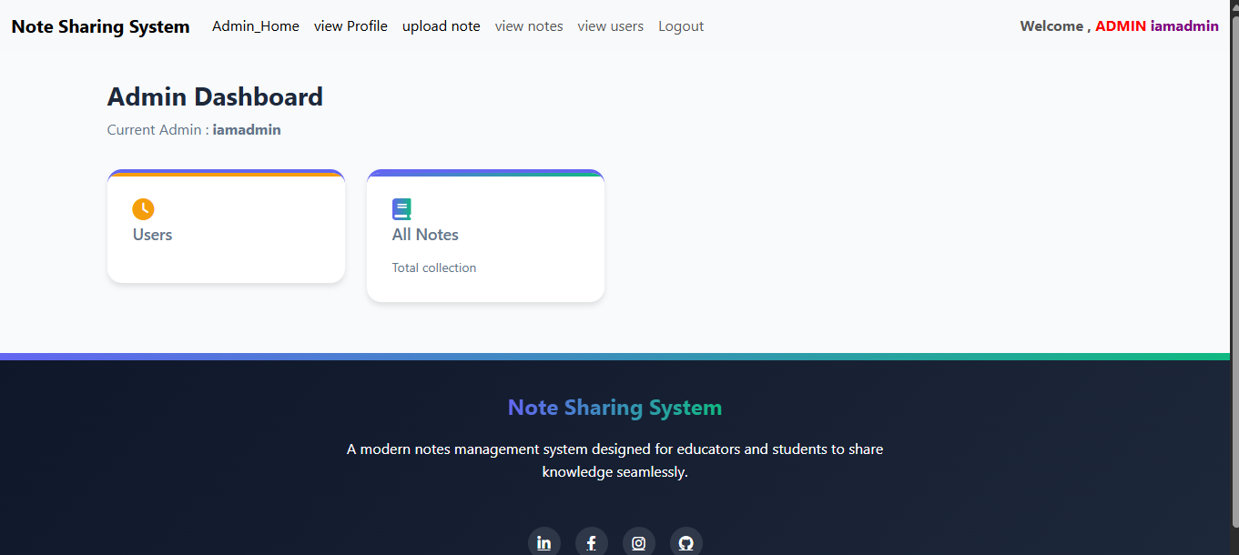

Fig 10: Admin Dashboard

1. **CHAPTER**

**IMPLEMENTATION AND TESTING**

* 1. **Implementation Approches**

The development of the **Note Sharing System** followed the **modular and iterative** approach, based on **Agile methodology**. The system was divided into multiple functional modules such as user authentication, note upload/download, search functionality, and admin controls. Each module was developed, tested, and refined in cycles before full system integration.

The use of Django allowed rapid development through reusable components, built-in admin functionalities, and its robust Object-Relational Mapping (ORM). Bootstrap made the frontend development efficient, with a consistent and responsive design across all devices.

**Implementation Steps:**

1. Setting up the Django project and app structure.
2. Creating custom user models and authentication logic.
3. Designing models for notes, users, role, departments, courses etc .
4. Implementing views and templates for each role (User, admin).
5. Handling file uploads with validation.
6. Developing search and filter logic for academic notes.
7. Testing each module before integration.
   1. **Coding Details and Code Efficiency**
      1. **Code Efficiency**

The system's core was built using **Python (Django)**, following clean and structured coding principles. Views were separated from templates to maintain the **MVT (Model-View-Template)** architecture. Bootstrap was used to build responsive forms, cards, and navigation elements.

To ensure optimal code efficiency:

* Django’s generic views were used where applicable to reduce boilerplate.
* Reusable components (like form templates and navbar) were created using Django template inheritance.
* File uploads were handled using Django’s built-in FileField with file type and size validation.
* Clean separation of business logic and presentation ensured maintainability.
  1. **Testing Approach**

Testing was a critical phase of the project to ensure all components worked correctly, both individually and as part of the integrated system. The approach included **unit testing**, **integration testing**, and **beta testing** to validate system behavior under different use cases.

Testing focused on:

* Functionality (Do features work as expected?)
* Usability (Is the UI intuitive?)
* Security (Is unauthorized access prevented?)
* Performance (Can it handle multiple note uploads and searches efficiently?)
  + 1. **Unit Testing**

**Unit Testing** was conducted for individual components such as:

* User registration and login
* Note upload and validation
* Search/filter functionality
* Role-based access control
  + 1. **Integrated Testing**

**Integration Testing** ensured that different modules worked together seamlessly. This included:

* Uploading a note and verifying it appears in the user dashboard
* Viewing notes uploaded by other users (based on roles)
* Searching and downloading notes based on filters

Scenarios were tested using realistic workflows from login to note sharing and access.

* + 1. **Beta Testing**

A limited **beta test** was conducted with selected students and faculty from the institution. They used the system under normal conditions and provided feedback on:

* Ease of use
* Navigation and performance
* Suggestions for additional features
  1. **Modification and Improvements**

Based on beta testing and internal reviews, few modifications were made to enhance the user experience:

* Improved the **search function** by including Categories.
* Added **file type and size validations** during upload.
* Updated the **navigation menu** for better accessibility.
  1. **Test Cases**

| **Test Case ID** | **Test Scenario** | **Input** | **Expected Output** | **Result** |
| --- | --- | --- | --- | --- |
| TC_01 | Login with correct credentials | Valid email and password | Redirect to user dashboard | Pass |
| TC_02 | Login with incorrect credentials | Wrong password | * Error message: “Invalid email or password” | Pass |
| TC_03 | Upload supported file type | .pdf or .docx | ****“Great Job!**** Your notes have been uploaded successfully.” | Pass |
| TC_04 | Upload unsupported file type | .exe or .zip | Error message: “****Oops!**** Only PDF, .doc, .docx JPG, and PNG files are allowed” | Pass |
| TC_05 | Search notes by title | “BEE 1st sem” | Display matching notes | Pass |
| TC_06 | Access admin panel (user role) | Logged-in as student | Access Denied | Pass |
| TC_07 | Download a note | Click on file link | File downloaded successfully | Pass |
| TC_08 | Submit note without file | Empty file field | Error message: ““****Oops!**** 'notes_file'” | Pass |
| TC_09 | View uploaded notes | Login as user | Uploaded notes listed in dashboard | Pass |
| TC_10 | Responsive layout test | Open on mobile device | Layout adapts correctly | Pass |

Table 2: Test Cases

1. **CHAPTER**

**RESULTS AND DISCUSSION**

* 1. **Test Reports**

The testing phase included validating the key functionalities of the **Note Sharing System**. The test cases were executed manually based on predefined scenarios. Below is the summary of the results for each test case:

* **TC_01 – Login with correct credentials**: The system successfully redirected users to their respective dashboards upon entering a valid email and password combination. ( Pass)
* **TC_02 – Login with incorrect credentials**: When an incorrect password was provided, the system displayed the appropriate error message: “Invalid email or password.” This confirms correct handling of invalid login attempts. ( Pass)
* **TC_03 – Upload supported file type**: Users were able to upload .pdf and .docx files successfully. The confirmation message “Great Job! Your notes have been uploaded successfully.” was shown, indicating successful file handling. ( Pass)
* **TC_04 – Upload unsupported file type**: Uploading unsupported formats like .exe or .zip triggered an appropriate error message: “Oops! Only PDF, .doc, .docx, JPG, and PNG files are allowed.” This validated the system’s input validation. ( Pass)
* **TC_05 – Search notes by title**: When searching for the title “BEE 1st sem,” the system accurately displayed all matching notes. This confirms that the search functionality is working as intended. ( Pass)
* **TC_06 – Access admin panel (user role)**: When a student attempted to access the admin panel, access was denied as expected. This validates the role-based access control feature. ( Pass)
* **TC_07 – Download a note**: Users were able to click on the file link and download the note without any issue, confirming that the download mechanism is functional. ( Pass)
* **TC_08 – Submit note without file**: When attempting to submit a note without selecting a file, the system responded with an appropriate error message: “Oops! 'notes_file'.” This confirms proper form validation. ( Pass)
* **TC_09 – View uploaded notes**: Logged-in users could successfully view their uploaded notes listed in the dashboard, validating the retrieval and display functions. ( Pass)
* **TC_10 – Responsive layout test**: The application interface adapted correctly on mobile devices, with layout and elements adjusting as expected. This ensures mobile responsiveness. ( Pass)

All 10 test cases passed successfully. The system’s core features—including login, file handling, role-based access, search, and responsiveness—have been tested and verified. This confirms that the Note Sharing System is stable and ready for use in a real-world academic environment.

* 1. **User Documentation**

User documentation was prepared to assist various stakeholders in using the system effectively.

#### **For Users:**

* **Login** using registered email and password.
* **Browse or search** notes by title or Category.
* **Upload notes** with proper categorization (subject, course)
* **Download** notes in supported file formats (PDF, DOCX).
* View personal note submissions (if upload is allowed).
* Access notes shared by other faculty members .
* **Delete own uploads**

#### **For Admin:**

* Full access to **user management** (view, delete users).
* Monitor and manage **all uploaded content**. (view, delete Notes).
* **Login** using registered email and password.
* **Browse or search** notes by title or Category.
* **Upload notes** with proper categorization (subject, course)
* **Download** notes in supported file formats (PDF, DOCX).
* View personal note submissions (if upload is allowed).
* Access notes shared by other faculty members .

1. **CHAPTER**

**CONCLUSION**

* 1. **Conclusion**

The **Note Sharing System** was successfully developed as a web-based platform to facilitate easy, secure, and centralized sharing of academic notes between students and faculty members. The system addresses the limitations of traditional note distribution methods by offering features such as user authentication, categorized uploads, downloadable content, and search functionality within an intuitive user interface.

By implementing this system, users can now efficiently share and access important academic materials, reducing dependency on physical notes and informal sharing methods. The development process followed modern web development practices using Django, Bootstrap, and SQLite, ensuring scalability, maintainability, and data security. The testing phase confirmed that all core functionalities perform reliably, making the system ready for institutional deployment.

* 1. **Significance of the System**

The significance of the **Note Sharing System** lies in its ability to:

* **Promote academic collaboration** by enabling students and faculty to exchange knowledge effectively.
* **Enhance accessibility** to notes and learning resources at any time, from anywhere.
* **Reduce administrative workload** related to note distribution and management.
* **Encourage environmentally friendly practices** by minimizing paper usage.
* **Ensure security and role-based access**, protecting academic content from unauthorized use.
* **Improve academic performance** by giving students equal access to quality resources.

The system supports the broader goal of digital transformation in education and serves as a foundational platform that can be extended with future features.

* 1. **Recommendation**

While the system fulfills its primary objectives, several recommendations can be considered for future enhancement:

* **Add a preview feature** for uploaded notes before downloading.
* **Implement file size limit warning and progress bar** during uploads.
* **Integrate email notifications** when new notes are uploaded in a specific course.
* **Enable comments or rating system** for better feedback on note quality.
* **Add cloud storage support** (e.g., Google Drive or AWS S3) for scalability.
* **Develop a mobile app version** for easier access on smartphones.

By implementing these recommendations, the system can evolve into a more interactive, scalable, and user-centric platform.

**REFERENCES**

[1] Bootstrap, Bootstrap Official Documentation, [Online]. Available: [https://getbootstrap.com](https://getbootstrap.com/). [Accessed: Jun. 25, 2025].

[2] BSCCIT Blog, “CSIT Notes, Projects, and Blog Articles,” BSCCSIT.com, [Online]. Available: [https://bsccsit.com](https://bsccsit.com/). [Accessed: Jun. 25, 2025].

[3] BSCCIT Note, “BSCCIT Notes, Model Questions and Resources,” BSCCITNote.com, [Online]. Available: [https://www.bsccitnote.com](https://www.bsccitnote.com/). [Accessed: Jun. 25, 2025].

[4] Django Software Foundation, Django Documentation, [Online]. Available: [https://docs.djangoproject.com](https://docs.djangoproject.com/). [Accessed: Jun. 25, 2025].

[5] Kailaba, “Educational Portal for Nepali Students,” Kailaba.com, [Online]. Available: [https://kailaba.com](https://kailaba.com/). [Accessed: Jun. 25, 2025].

[6] Study Notes Nepal, “Study Notes for TU, PU, KU, and more,” StudyNotesNepal.com, [Online]. Available: [https://studynotesnepal.com](https://studynotesnepal.com/). [Accessed: Jun. 25, 2025].